SET NINE 2018
PRIMARY SEVEN
ENGLISH
Time allowed: 2 hours 15 minutes

Index No.

Candidate’s Name: _________________________________________________
Candidate’s Signature: ______________________________________________
School Name: ______________________________________________________
FOR EXAMINER’S USE ONLY
Read the following instructions carefully:
- The paper has two sections: A and B
- Section A Sub-Section I has 30 questions (30 marks)
FOR EXAMINER’S USE ONLY

Qn. No | MARK | SIGN
1 – 16
17– 26
27 – 35
36 – 44
45 – 50
51 – 52
53
54
55
TOTAL

and Sub-Section II has 20 questions (20 marks)
- Section B has 5 questions (50 marks)
- Answer ALL questions. All answers to both Sections A
and B must be written in the spaces provided.
- All answers must be written using a blue or black ball
point pen or ink. Diagrams should be drawn in pencil.
- Unnecessary crossing of work may lead to loss of marks.
- Any handwriting that cannot be easily read may lead to
loss of marks.
- Do not fill anything in the boxes indicated
For Examiner’s use only.
Turn over

SECTION A
Sub-section I
In questions 1 – 10, use the correct form of the given word to complete the sentence.
1. You should always ______________________ your letter in an envelope. (close)
2. The P.7 pupils are doing their work very ____________________ . (noise)
3. I was filled with _______________________ when I saw the old man being dragged by KCCA law enforcement officers. (pitiful)
4. The three ___________________ we have in P.7 C were given to us by the school director. (shelf)
5. The pen she has lent you is not _______________________ . (she)
6. Having _________________ our tests to the teacher for marking, we went for break. (take).
7. If the baker _____________________ me the bread I paid for, I wouldn’t have complained. (gave)
8. None of the P.7 candidates __________________ well nowadays. (write)
9. My teachers of English hate _____________________ to disorganised debates. (listen)
10. I took a ________________ route than he on my way home. (short)
Arrange the words below in their order of English alphabet.
11. conclude, address, body, valediction, date
____________________________________________________________________
12. mechanic, machine, mechanics, machinery
____________________________________________________________________
In questions 13 – 17, fill the gaps with the most suitable word.
13. Daddy has hardly ________________________ money to buy for me a phone.
14. She never called me _____________________ the fact that she had some airtime on her phone.
15. ___________________________ the mechanic nor the driver was polite.
16. We are accustomed _______________________ eating beans and bread for lunch.
17. The bitch and its _______________________ have been vaccinated.
In questions 18 to 20, write the correct abbreviations / contractions.
18. pages: _____________________________________________________________
19. would not ___________________________________________________________
20. Primary Leaving Examination: ___________________________________________
For questions 21 and 22, re – organise the given words to form sensible sentences.
21. debate the in participate Did audience the?
____________________________________________________________________
22. has Daddy’s permit a driver driving.
____________________________________________________________________
23. easy was how examination the English!
____________________________________________________________________
Rewrite the sentences below giving the plural form of the underlined words.
24. The radio I bought had no antennas.
____________________________________________________________________
25. You should study the examination analysis.
____________________________________________________________________
Rewrite the sentences in question 26 and 27, giving the opposites of the underlined words.
26. People like using traditional means of communication.
____________________________________________________________________
27. The occupants at the front forgot to fasten their seat belts.
____________________________________________________________________
Replace the underlined words with one word.
28. I have to take back the car jack to Mr. Bogere.
____________________________________________________________________
29. Our class teacher has hung the list showing responsibilities to be done by the pupils in the classroom.
____________________________________________________________________
30. The carpenter who lives near our home does his work in a skilful way.
____________________________________________________________________
Sub – section II
In questions 31 – 50, rewrite the sentences as instructed in brackets.
31. I failed to pass my beginning of term one exam. I did not pay attention during lessons. (Join the sentences using…….because……..)
____________________________________________________________________
____________________________________________________________________
32. We did many pieces of homework in English. We performed well.
(Join the sentences and use: The……the……)
____________________________________________________________________
____________________________________________________________________
33. I am more interested in digging than in baking during holidays.
(Rewrite the sentence using: ………… …enjoy…………..….)
____________________________________________________________________
____________________________________________________________________
34. The examination room had bed bugs. We used in the examination room for our Maths exam. (Join the sentences using: …………..which…..)
____________________________________________________________________
____________________________________________________________________
35. The third term holiday was very long. (Rewrite and end………………!)
____________________________________________________________________
____________________________________________________________________
36. All P. 7 candidates wrote good official letters. (Begin: Each………)
____________________________________________________________________
37. Waibale dipped my cattle yesterday. (Begin: My cattle…….)
____________________________________________________________________
38. Stop writing such letters, __________________?
(Rewrite the statement and supply a suitable question tag)
____________________________________________________________________
____________________________________________________________________
39. “ Why did you miss the English test, Atusasira?” Nakintu asked.
(Rewrite the sentence and use….wanted to know…….)
____________________________________________________________________
____________________________________________________________________
40. The invigilator checked my pocket. The invigilator checked my pencil case.
(Join the sentences using …both…….)
____________________________________________________________________
____________________________________________________________________
41. Taddewo will be repairing my car tomorrow. (Use…….going to…………)
____________________________________________________________________
____________________________________________________________________
42. My brother bought another phone, but it was not necessary.
(Rewrite the sentence and use ….needn’t…….)
____________________________________________________________________
____________________________________________________________________
43. He was appointed the head of P.7. Every teacher was pleased. (Begin: His…………)
____________________________________________________________________
____________________________________________________________________
44. Candidates should plan for their holidays wisely. (Use…ought to………….)
____________________________________________________________________
____________________________________________________________________
45. Unless you get a UNEB index number, you will not sit P.L.E. this year.
(Begin: If…….)
____________________________________________________________________
____________________________________________________________________
46. The baking test was so easy that every candidate passed it.
(Rewrite and use …..too….to…..)
____________________________________________________________________
____________________________________________________________________
47. I have lost my phone. I bought the phone at twenty dollars.
(Join and end …phone.)
____________________________________________________________________
____________________________________________________________________
48. The technician started repairing my computer at 9:00 a.m. He is still repairing the computer.
(Rewrite and join the sentences using: …………….…since………………....)
____________________________________________________________________
____________________________________________________________________
49. Could you lend me your laptop, please? (Begin: May……)
____________________________________________________________________
____________________________________________________________________
50. Angella has a nice phone. I have a nice phone too.
(Join the sentences and use ….and so…….)
____________________________________________________________________
____________________________________________________________________
SECTION B
51. Read the poem below carefully, and in full sentences, answer the questions that follow.
Examinations ! Examinations!
The mere word examinations,
Makes me tremble when it is mentioned,
I hate examinations!
You make me scared and stressed all the time,
Yet I cannot escape you!
You are the door through which I must pass.

Examinations ! Examinations!
Why do you make me spend sleepless nights revising my notes?
Preparing for you when the timetable is put up,
Put up on the school noticeboard and in all the classrooms,
This puts every P. 7 candidate on tension,
Because of fearing you
Some students start faking excuses about sickness,
In order to avoid you!

Examinations ! Examinations!
When will my dream come true?
To wake up one day and find you no more,
I cannot imagine how happy I will be,
When your name exists no more,
But I know that,
One day, God will answer my prayers.
(By Sunday Ismail, Kasaba Modern School)
Questions
(a) How many verses does the poem have?
____________________________________________________________________
____________________________________________________________________
(b) Who wrote this poem?
____________________________________________________________________
____________________________________________________________________
(c) Why doesn’t the writer of the poem sleep?
____________________________________________________________________
____________________________________________________________________
(d) In which class is the writer of the poem?
____________________________________________________________________
(e) How does the writer of the poem prepare himself for the examination?
____________________________________________________________________
____________________________________________________________________
(f) Suggest another word or words that can be used to mean the same as the following in the poem:
(i) put up ______________________________________________________________
(ii) through which________________________________________________________
(g) Where is the examination timetable displayed according to the poem?
____________________________________________________________________
____________________________________________________________________
(h) What happens when the examination timetable is displayed on the noticeboard and classrooms?
____________________________________________________________________
____________________________________________________________________
(i) Suggest a suitable title for the poem above.
____________________________________________________________________
____________________________________________________________________
52. Study the report card below carefully, and answer in full sentences, the questions about it.

REPORT CARD
KAZAANA JUNIOR SCHOOL
P.O.BOX 1327
TORORO DISTRICT
TERMLY REPORT CARD P.7B
BEGINNING OF TERM I EXAMS, 2017
Name: AKELLO TIINO
Age : 12 years
Position: 9th out of 40
SUBJECT SCORE Agg SUBJECT TEACHER
Mathematics 94 2 Kaleebo Sam
Social studies 90 2 Ndobole Peter
Science 94 2 Ocaya Ivan
English 97 1 Abeja Claire
Total 375 7

Class teacher’s comment:. This is a good beginning. However, you can perform better than this.
Signature: Ivan Ocaya
Head teacher’s comment:. Aim at aggregate four.
Signature: Talemwa Johnson
Date: 20th April 2017

Questions
(a) Whose report card is shown above?
____________________________________________________________________
(b) What was her position in the class that term?
____________________________________________________________________
(c) How many candidates were in P.7 B according to the report?
____________________________________________________________________
(d) In which school is the owner of the report card above?
____________________________________________________________________
(e) In which subject did she score the least mark?
____________________________________________________________________
(f) Where is Kazaana Junior School found?
____________________________________________________________________
(g) How old is the owner of this report card?
____________________________________________________________________
(h) Apart from teaching Science, what else does Mr. Ocaya Ivan do for this class?
____________________________________________________________________
(i) Why do you think Akello Tiino performed best in English?
____________________________________________________________________
(j) When did the head teacher sign the report card?
____________________________________________________________________
53. Use the words given in the list to fill in the blank spaces in the passage below.
overtaking, Although, could, by, second – hand, towed, direction, what, at,

a lot

Ntale Buys a vehicle.
Ntale was extremely happy when he bought his __________________ car. __________________ it was old, he liked it very much. He knew that there were __________________________ of good mechanics near his place of work who _______________________ help him repair his car in case it broke down.

One day, Ntale decided to travel _____________________ his car to Kibale District, his home area. He started the car engine and he drove _________________.
When he reached Masaka Highway, he drove very fast. No sooner had he started _________________ other cars than the car engine suddenly stopped.

Luckily, a breakdown truck came from the opposite _________________. The driver of the breakdown truck got out and asked him ____________________ had happeneded to his (Ntale’s) car. Ntale answered him that the car engine had stopped, so he needed help from him. The breakdown vehicle _________________ Ntale’s car to a nearby garage.

54. Read the dialogue below very carefully, and in full sentences, answer the questions about it.
Michelle: Good afternoon, Mellisa.
Mellisa: Good afternoon, Michelle.
Michelle: Long time, Mellisa.
Mellisa: Long time, Michelle. I have not seen you since November last year.
Michelle: Where did you spend your school holidays?
Mellisa: I spent them at my aunt’s place in Kabale.
Michelle: Wow! In Kabale, how did you cope with the weather there?
Mellisa: I tell you, Michelle? The place is too cold for life. But by the second week,
I had got used to the weather.
Michelle: Had you planned to have your holiday there before we broke up for holidays?
Mellisa: Oh! Yes! I had done so. I made my plans in October.
Michelle: I am sure you enjoyed your holidays. Have a nice day.
Mellisa: And you, too.
Questions
(a) Who are the people participating in the dialogue?
____________________________________________________________________
(b) At what time did the dialogue take place?
____________________________________________________________________
(c) When did Mellisa last meet Michelle according to the dialogue?
____________________________________________________________________
(d) Where did Mellisa spend her school holidays?
____________________________________________________________________
(e) How does Mellisa describe the weather in Kabale according to the dialogue?
____________________________________________________________________
(f) After how long did Mellisa get used to the harsh weather of this area?
____________________________________________________________________
(g) What did Michelle do before breaking up for holidays?
____________________________________________________________________
(h) Why do you think a holiday is important to a pupil like you?
_____________________________________________________________________

(i) In which month did Mellisa make her holiday plan?
____________________________________________________________________
(j) Suggest a suitable title for the dialogue.
____________________________________________________________________
55. Below is a picture story about an Examination at Mpererwe Junior Primary School. In only one sentence, describe what is taking place in each picture. You may use the words given below in your sentence construction.
female invigilator, check in notes, briefing, candidates lamenting, try to remember the answers, headmaster, cheering, give out exams, collect examination scripts, give out question papers

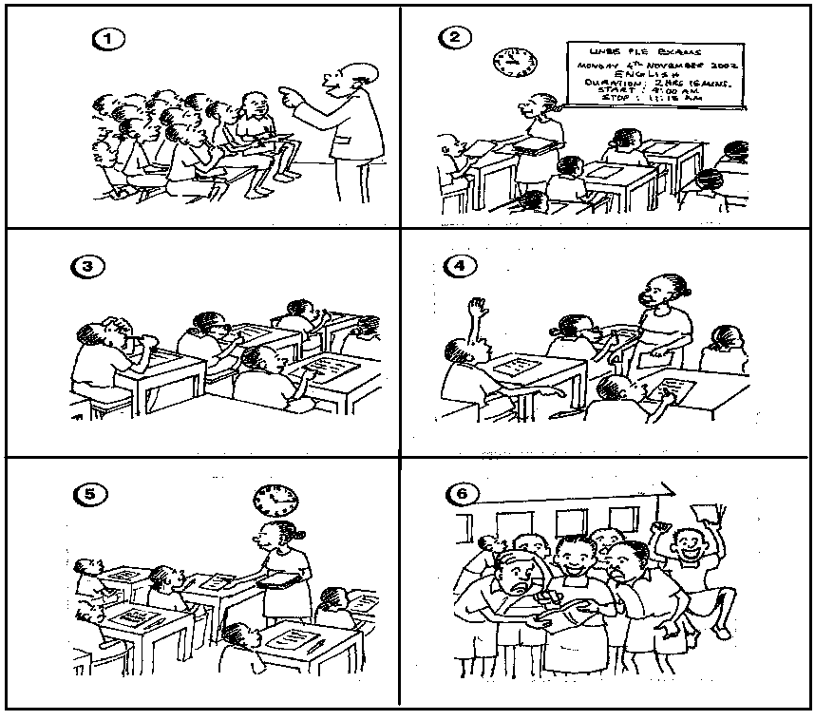

(a) ____________________________________________________________________
____________________________________________________________________

(b) ____________________________________________________________________
____________________________________________________________________
(c) ____________________________________________________________________
____________________________________________________________________
(d) ____________________________________________________________________
____________________________________________________________________
(e) ____________________________________________________________________
____________________________________________________________________
(f) ____________________________________________________________________
____________________________________________________________________
(g) Why do you think the candidate in picture 3 has put his finger on the head?
__________________________________________________________________
__________________________________________________________________
(h) From which school are the candidates in the picture story?
__________________________________________________________________
__________________________________________________________________
(i) Which examination do you think these pupils are sitting?
__________________________________________________________________
__________________________________________________________________
(j) Why do you think the candidates in picture 6 are happy?
___________________________________________________________________
___________________________________________________________________

